Recursive function

1. Write a program where the recursive function calculates the sum of N numbers

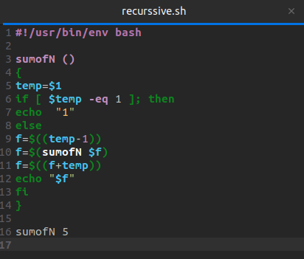

Terminal

